E-COMMERCE SALES DATA CLEANING REPORT
Data Quality Assessment & Cleaning Summary

Project Overview
This project focused on preparing an e-commerce sales dataset for analysis by identifying and resolving data quality issues that could affect reporting accuracy and business insights.

Dataset Information
- Dataset Type: E-Commerce Sales Data
- Number of Records: 1,200
- Industry: Retail / E-Commerce
- Objective: Ensure data quality and consistency before performing exploratory data analysis (EDA).

Data Quality Assessment
The dataset was reviewed for common data quality issues, including:
- Missing values
- Duplicate records
- Inconsistent data entries
- Data formatting issues

Findings
Data Quality Check | Result
Missing Values | 309 blanks found in CouponCode column
Duplicate Records | 0 duplicates found
Date Format Issues | None detected
Structural Issues | None detected

Data Cleaning Actions Performed

1. Missing Value Treatment
A total of 309 blank records were identified in the CouponCode column. Rather than removing these records, the missing values were replaced with:
“NO COUPON”
This approach was chosen because the blank values most likely represented customers who completed purchases without applying a promotional code.
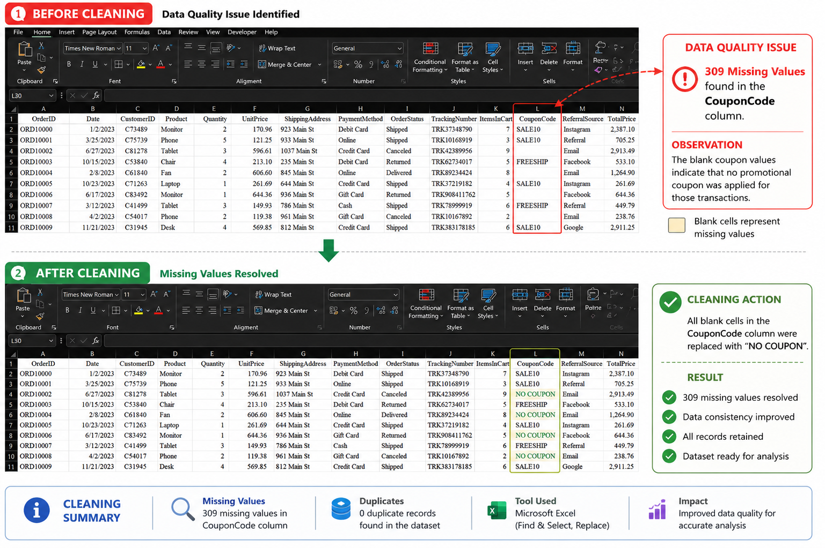

Business Justification
The missing CouponCode values were not treated as errors because they likely represented customers who completed purchases without applying a promotional offer.
Replacing blank values with “NO COUPON” preserved all transaction records while improving data consistency and enabling accurate analysis of coupon usage behaviour.

2. Duplicate Check
The dataset was checked for duplicate records.
- No duplicate records were found.
- No rows were removed.
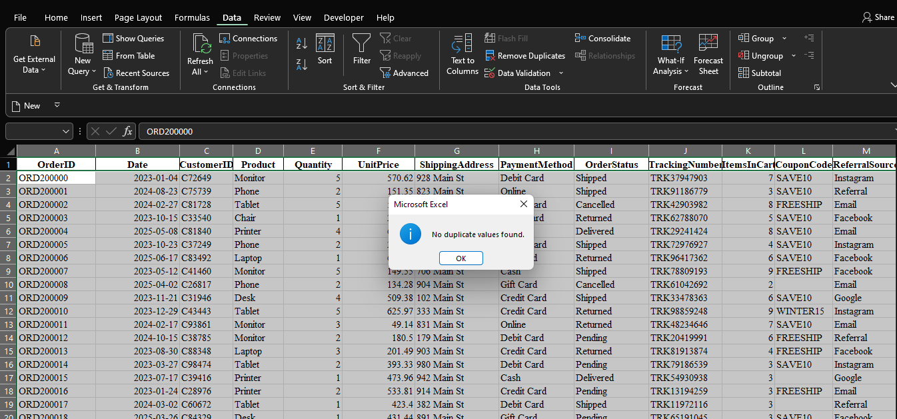

Outcome
The dataset was successfully cleaned and prepared for further analysis. The cleaned dataset provides a reliable foundation for:
- Exploratory Data Analysis (EDA)
- Customer Purchase Analysis
- Revenue Analysis
- Product Performance Analysis
- Marketing Campaign Evaluation

Key Deliverables
✓ Missing value assessment completed
✓ Coupon Code blanks treated and standardised
✓ Duplicate record validation completed
✓ Clean dataset prepared for analysis
✓ Dataset ready for exploratory data analysis (EDA)

Tools Used
- Microsoft Excel
- Power Query

Prepared by:
Favour Oladapo
Data Analytics Intern

